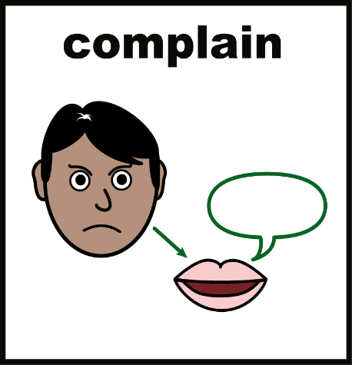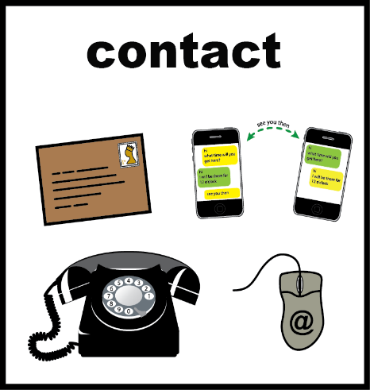

If you want to complain about your care let us know by:

-Speaking to a carer you trust.

- Speak to the Manager

**Jenny Daynes**

- Calling **07551 312765** and say you want a feedback call.

Email us rosterhomecare@gmail.com

We will ask you questions and listen to what you have to say about your care.

Your feedback will help us to get better and provide the best care possible.

If you would like to complain to social services about Roster Home Care please call:

Norfolk Safeguarding number: 0344 800 8020

Norfolk Social Services: 0344 800 8020

Or Care Quality Commission: 03000 616161

